AWS Switch Role

**Contents**

**1.** **What is AWS Switch Roles?** 3

**2.** **How to Switch Roles?** 3

# **What is AWS Switch Roles?**

* A role specifies a set of permissions that you can use to access AWS resources that you need. It is similar to a user in AWS Identity and Access Management (IAM).
* When you sign in as a user, you get a specific set of permissions. However, you don't sign in to a role, but once signed in you can switch to a role.
* This temporarily sets aside your original user permissions and instead gives you the permissions assigned to the role.
* The role can be in your own account or any other AWS account.
* When you switch roles in the AWS Management Console, the console always uses your original credentials to authorize the switch.
* This applies whether you sign in as an IAM user, as a SAML-federated role, or as a web-identity federated role.
* For example, if you switch to RoleA, IAM uses your original user or federated role credentials to determine whether you are allowed to assume RoleA.
* If you then switch to RoleB while you are using RoleA, AWS still uses your original user or federated role credentials to authorize the switch, not the credentials for Role A.

# **How to Switch Roles?**

* 1. There are two AWS accounts Master Account ‘X’ and Master Account ‘Y’
  2. Account X has created an IAM user i.e., user ‘A’
  3. Account Y has created an IAM user i.e., user ‘B’
  4. Considering to switch from user ‘A’ to user ‘B’.
  5. In order to switch User ‘B’ s account User ‘B’ should create a role Permission for User ‘A’s IAM account
  6. In user ‘B’s account Go to IAM -> Roles -> Create role -> Another AWS Account ->

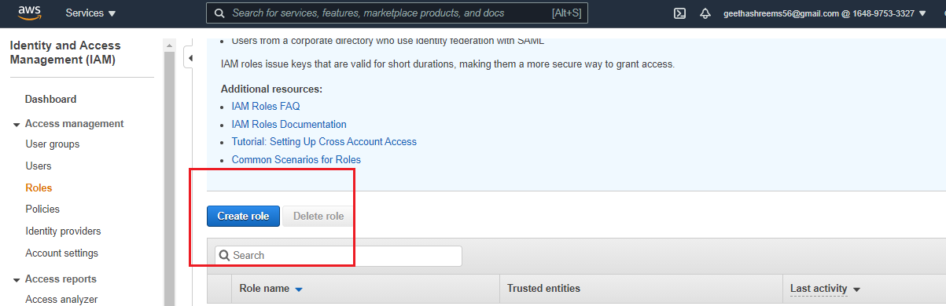

In Account ID: <Give User ‘A’s account ID -> Next: permissions

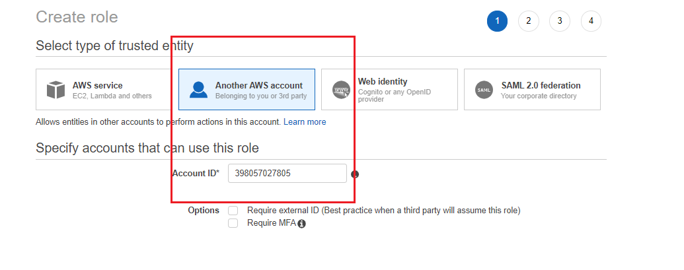

In Attach Permission Policies -> Select Administrator Access

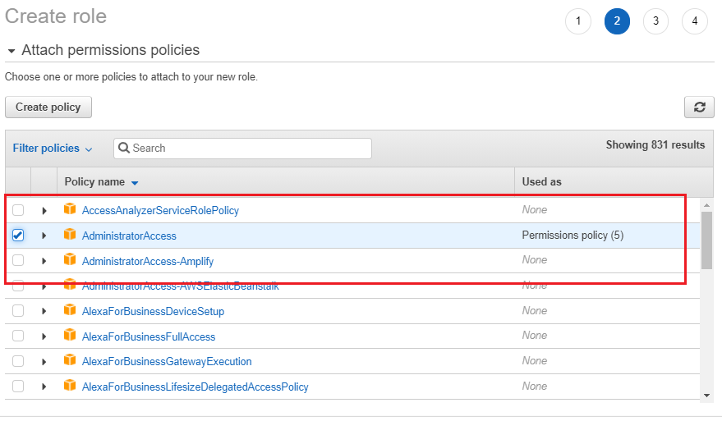

In Tags -> name of your choice

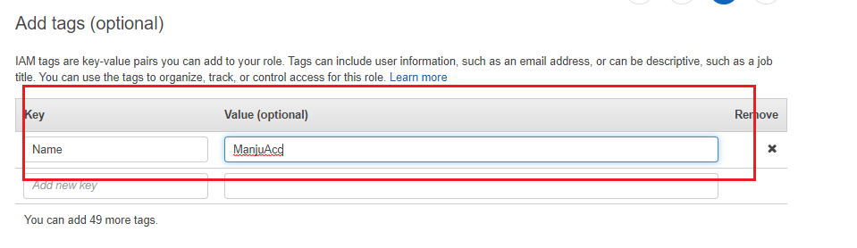

In review -> Role name: < name of your choice> -> create role.

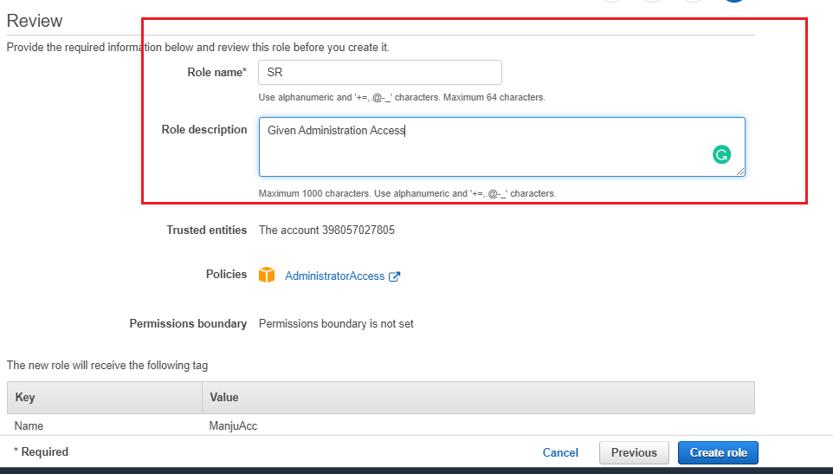

* 1. In user ‘A’s account Go to IAM -> Users -> click on the User ‘A’ IAM account

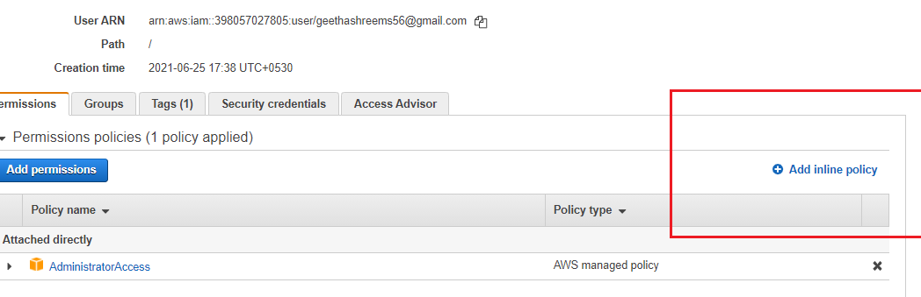

-> Click on Add inline policy -> Select JSON and add the following snippet:

* 1. Resource": "arn:aws:iam::398057027805:role/SR – This line is taken from User ‘B’s role ARN.
  2. SR is the role name created in User ‘B’s account.

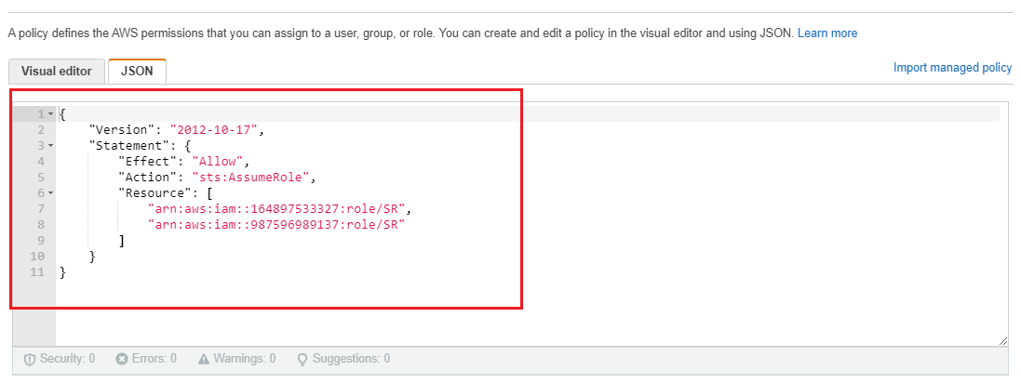



* 1. The click on review policy ->

In review Policy -> name: < name of your choice> -> create policy

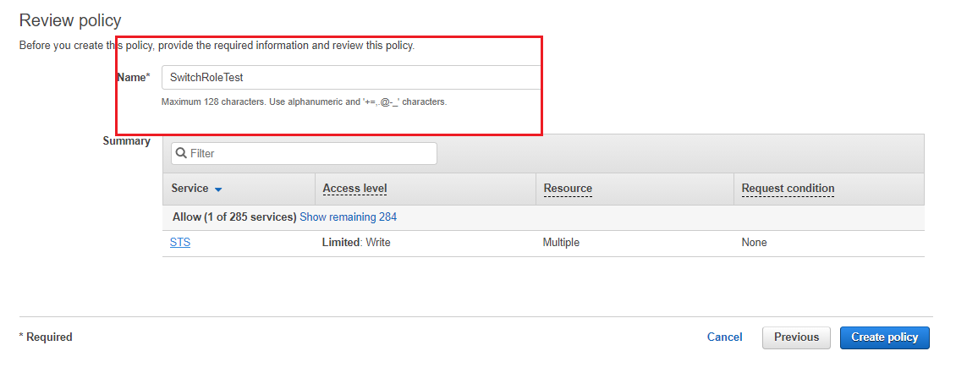

* 1. Now In user ‘A’s account -> Click on the IAM ID -> click on Switch role ->

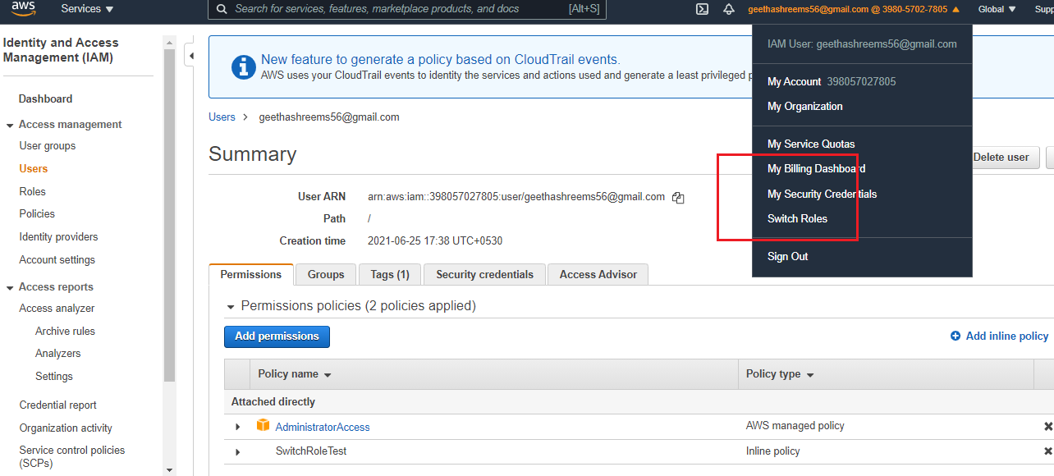

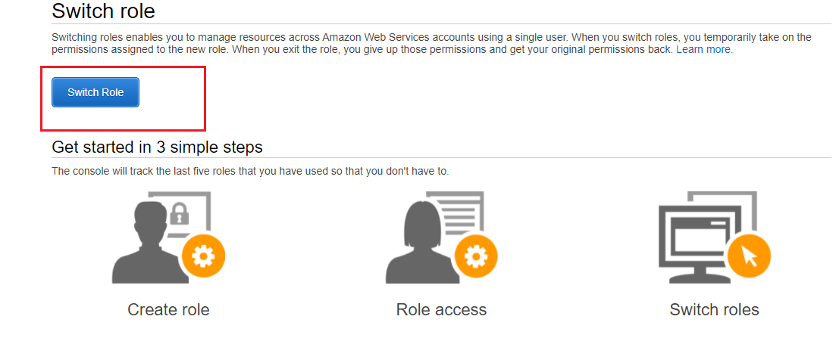

Account: <Put User ‘B’s account ID> -> Role: which was created earlier

-> Display Name: <Optional> -> Switch role.

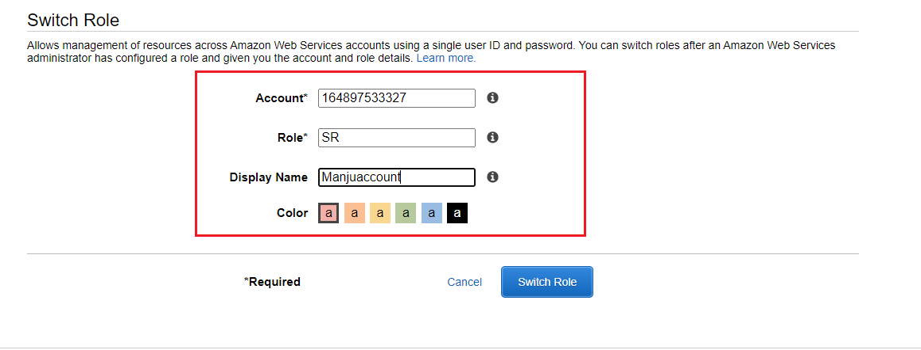

* 1. To switch back from existing account Go to -> click on account ID->select Back to Use A Account.

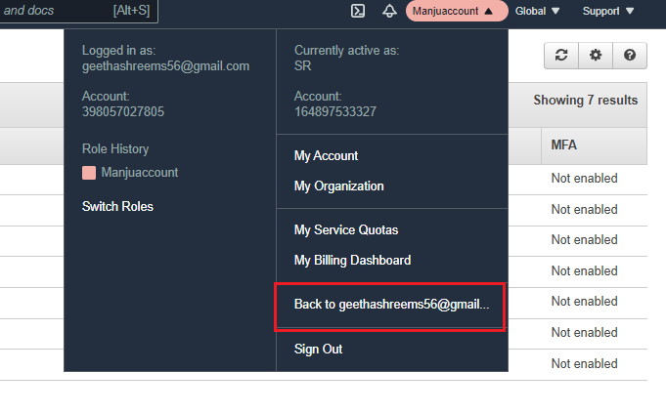

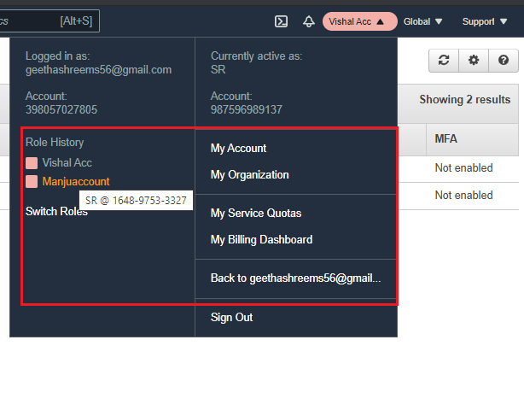

Note: In order to switch to multiple accounts we must add Multiple role ARN to the “Resource” Variable.